

Requirement & Design Specification

**Gas Management System (GMS)**

**Version: 1.0**

– Hanoi, May 2024 –

# **Record of Changes**

|  |  |  |  |  |
| --- | --- | --- | --- | --- |
| Version | Date | A* M, D | In charge | Change Description |
| V1.0 | 18/05 | A | DucHQMHE180232 | Create document |
| V1.1 | 20/05 | A | AnhTHVHS150463 | Add II. Requirement Specification  1. Common function |
|  |  |  |  |  |
|  |  |  |  |  |
|  |  |  |  |  |
|  |  |  |  |  |
|  |  |  |  |  |
|  |  |  |  |  |
|  |  |  |  |  |
|  |  |  |  |  |
|  |  |  |  |  |
|  |  |  |  |  |

**\*A – Added, M – Modified, D - Deleted**

Contents

**Record of Changes** 2

**I. Overview** 4

1. User Requirements 4

1.1 Actors 4

1.2 Use case 4

2. Overall Functionalities 8

2.1 Screen Flow 8

2.2 Screen Descriptions 9

2.3 Screen Authorization 11

2.4 Non-UI Functions 12

3. System High Level Design 13

3.1 Database Design 13

3.2 Code package 15

**II. Requirement Specifications** 17

1. Common Functions 17

1.1 Register Account 17

1.2 Login 17

1.3 Forgot Password 18

1.4 Logout 18

2. Admin Functions 19

2.1 Account Management 19

2.2 Category Management 20

2.3 Product Management 22

2.4 News Management 24

2.5 Supplier Management 26

2.6 Order Management 28

# **I. Overview**

## 1. User Requirements

### 1.1 Actors

|  |  |  |
| --- | --- | --- |
| **#** | **Actor** | **Description** |
| 1 | Administrator | Admin has the highest level of access and control over the system. Admins are responsible for managing the overall system settings, maintaining user roles and permissions, overseeing data integrity, and ensuring the system operates smoothly. |
| 2 | Staff | Staff can access to the features and data necessary to perform their job functions but with more limited permissions compared to admins. Staff roles include product management, customer management, content management, or service providers. |
| 3 | Customer | A customer is an end-user who interacts with the system primarily to purchase products or services. Customers have access to features that allow them to browse offerings, make purchases, track orders, and manage their accounts. |
| 4 | Guest | A guest is a user who interacts with the system without making a purchase. Guests typically have the most limited access, allowing them to browse public information, view products or services, and register an account. They may potentially become customer. |

### 1.2 Use case

**a. Diagrams**

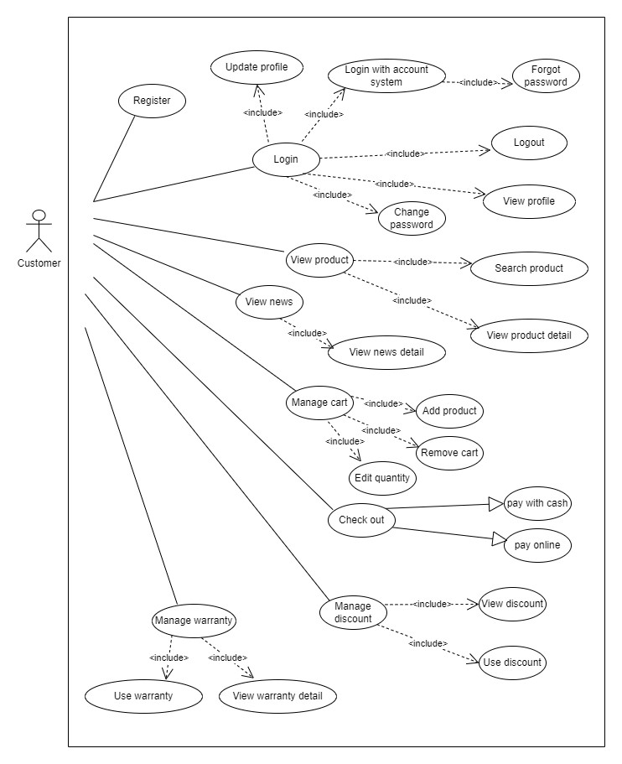

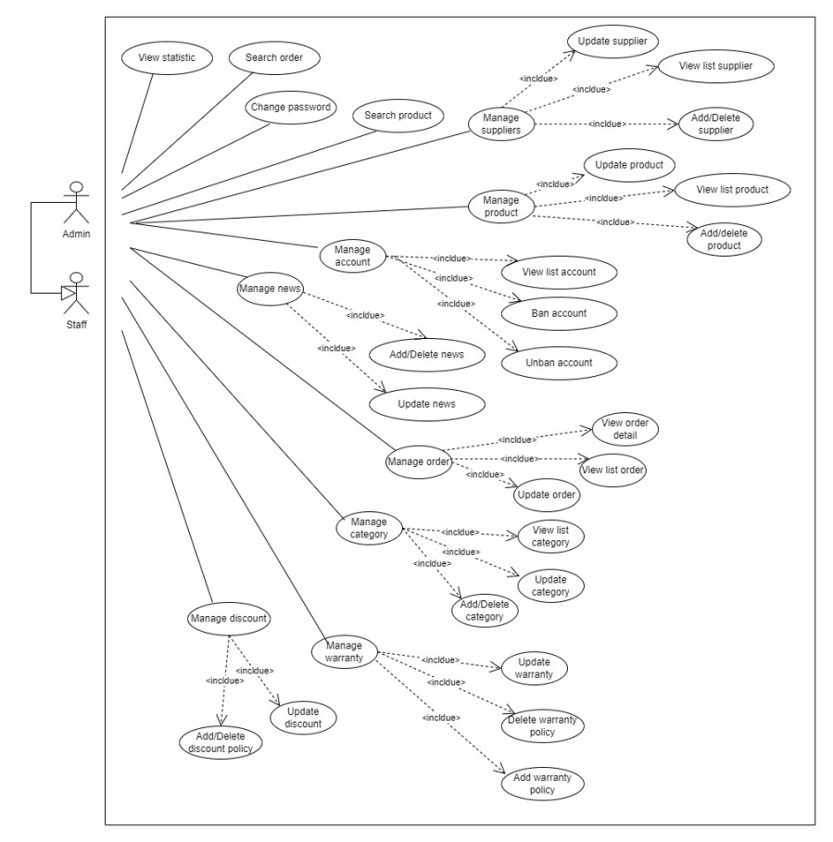

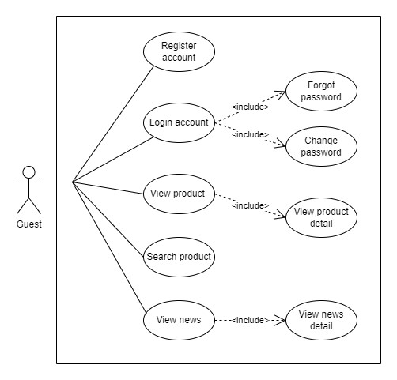

**b. Descriptions**

|  |  |  |  |
| --- | --- | --- | --- |
| **ID** | **Feature** | **Use Case** | **Use Case Description** |
| 01 | User registration | Register new user | Allow a new user to create an account in the system. The user provides personal information such as name, email, and password. The system validates the information, creates a new user record, and sends a confirmation email to the user. |
| 02 | User login | Authenticate user | Allow an existing user to log into the system. The user enters their username and password. The system verifies the credentials and grants access to the user’s account if the credentials are valid. |
| 03 | View product | Browse product | Allow a customer or guest to browse through the list of available products. The system displays product details including name, image, category, description, price, and availability. Users can filter and search for specific products. |
| 04 | Shopping cart management | Manage cart | Allow a customer to manage the contents of their shopping cart. Customers can add products, update quantities, view cart details, and remove items. |
| 05 | News viewing | Browse news | Allow users to view the latest news related to gas. Users can browse, search, and filter news based on categories, tags, or publication dates. |
| 06 | Payment process | Checkout | This use case enables customers to complete their purchases by processing payments securely. The system supports two payment methods, verifies payment details, and confirms the transaction. |
| 07 | Warranty management by customer | Manage warranty by customer | This use case enables customers to view and claim warranties for their purchased products. The system provides comprehensive details about warranty coverage, expiry dates, and claim procedures. |
| 08 | Discount management by customer | Manage discount by customer | Customers can view and apply discounts to their purchases, and the system ensures the correct discount is applied during the checkout process. |
| 09 | Analytic and reporting | View statistic | Allow admins and staff to view various statistics related to the system’s operations. The system generates and displays analytical data including sales performance, customer behavior and product popularity. |
| 10 | Product management | Manage product | Allows admins to add, update, and delete products within the system. It also includes managing product details such as images, descriptions, pricing, category, unit on stock,... |
| 11 | Supplier management | Manage supplier | Enables admins to manage supplier information, maintain relationships with suppliers, and track product sourcing. |
| 12 | Account management by admin | Manage account by admin | Enable admins to manage customer accounts within the system. Admins can perform various actions such as creating new accounts, updating account details, and deactivating or deleting accounts when necessary. |
| 13 | News management | Manage news | Enables admins to manage news articles or updates within the system. Admins can create, update, delete, and publish news content to keep users informed about important announcements, events, or developments related to the platform or organization. |
| 14 | Order management by admin | Manage order by admin | Enable admins to manage orders within the system. Admins can view order details, update order statuses, track shipments, and handle any issues or requests related to orders. |
| 15 | Category management | Manage category | Enable admins to manage product categories within the system. Admins can create, update, delete, and organize categories to ensure that products are properly classified and easy to navigate for customers. |
| 16 | Warranty management by admin | Manage warranty by admin | Enable admins to manage product warranties within the system. Admins can create, update, and track warranty information for products sold on the platform. |
| 17 | Discount management by admin | Manage discount by admin | Enables admins to manage discounts within the system. Admins can create, update, delete, and apply discounts to products or orders to attract customers, increase sales, and promote specific products or categories. |
| 18 | Account management by user | Manage account by user | Allow users to manage their accounts within the system. Users can perform various actions such as updating personal information, changing passwords, and accessing account-related settings. |

## 2. Overall Functionalities

### 2.1 Screen Flow

**a. Customer**

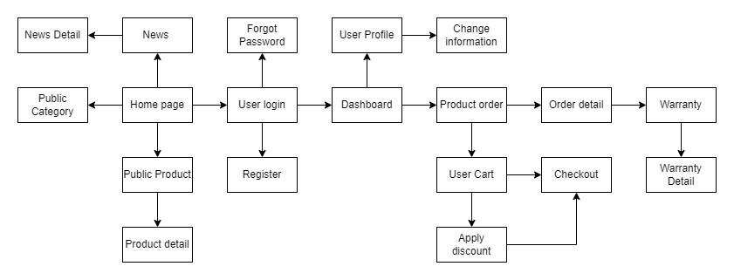

**b. Admin/Staff**

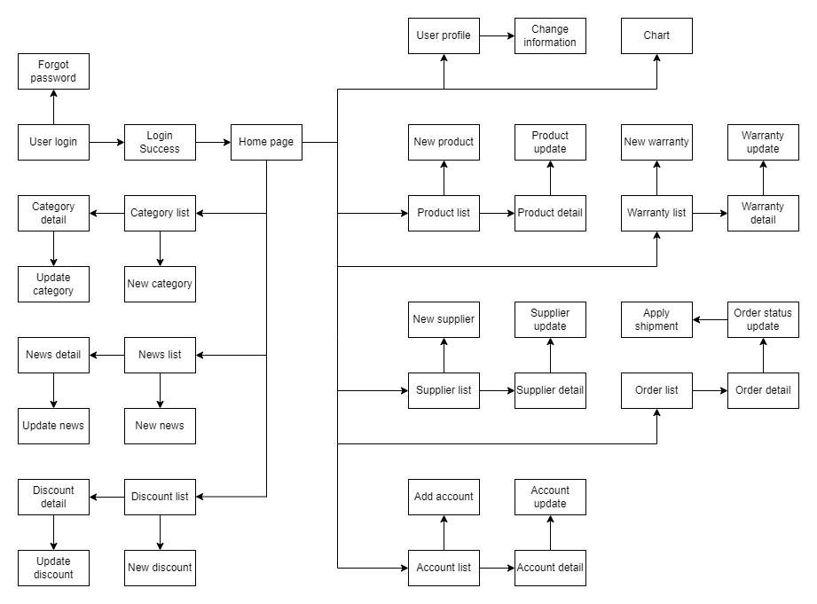

**c. Guest**

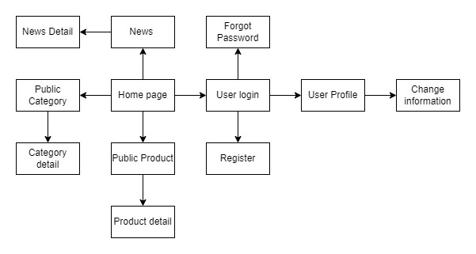

### 2.2 Screen Descriptions

|  |  |  |  |
| --- | --- | --- | --- |
| **#** | **Feature** | **Screen** | **Description** |
| 1 | User Authentication | Login | Enter username and password, then click "Login." If user have trouble logging in, use "Forgot Password?" to reset your password or "Sign Up" to create a new account. |
| 2 | User Authentication | Register | Fill in your personal information, including username, email, and password, then click "Sign Up" to create a new account. If user encounter any issues, ensure all required fields are filled correctly and try again. |
| 3 | User Authentication | Forgot password | The user clicks the "Forgot Password?" link, enters their registered email address, and follows the instructions sent to their email to reset their password. If the user encounters any issues, they should check their spam folder or re-enter their email address correctly. |
| 4 | Display content | Display product list | The user browses the product list page, where multiple products are listed with brief descriptions, images, and prices. The user can filter and sort products based on categories, price range, or other criteria, and click on individual products for more details. |
| 5 | Display content | Display product | The user navigates to the product page, where product details, images, pricing, and availability are displayed. The user can view specifications, add product to cart, and check related products. |
| 6 | Display content | Display news list | The user accesses the news list page, where multiple news articles are listed with titles, brief summaries, and publication dates. The user can click on individual articles to read the full content and have options to filter news by categories. |
| 7 | Display content | Display news | The user views the full content of a news article, including the title, publication date, and article body. |
| 8 | Display content | Display category | The user accesses the category page, where products are organized into specific categories. Each category is displayed with a name and a brief description. The user can click on a category to view the products within that category. |
| 9 | Display content | User profile | The user accesses their profile page, where their personal information, such as username, email, and profile picture, is displayed. The user can view and edit their profile details, manage account settings, view order history. |
| 10 | Order products | View cart | The user accesses the cart page, where all items added for purchase are displayed. Each item is listed with its name, quantity, price. The user can update quantities, remove items, or proceed to checkout. The page also display the total order amount. |
| 11 | Order products | Apply discount | User can enter a discount code or select from available discounts to apply to their order. The page displays the applied discount amount and updates the order total accordingly. |
| 12 | Order products | Checkout | User review their cart contents, apply any discounts, and select payment options. |
| 13 | Product warranty | Product warranty | The page includes information such as the duration of the warranty, coverage details, terms and conditions, and any applicable limitations or exclusions. |
| 14 | Website statistic | View chart | Admin accesses the chart visualization page, where graphical representations of data are displayed for analysis and decision-making purposes. |
| 15 | Manage content | Product list | The admin accesses the product management page, where a comprehensive list of all products available on the platform is displayed. Each product is listed with details such as name, category, price, image, and have options like delete or update. |
| 16 | Manage website | Update product | Admins can modify product details such as name, description, price, and inventory status directly from this page, ensuring accurate and up-to-date product information across the platform. |
| 17 | Manage website | Warranty list | Each warranty is listed with details such as product name, warranty duration, coverage details, and status. |
| 18 | Manage website | Update warranty | Admins can modify warranty details such as duration, coverage, terms, and conditions directly from this page, ensuring accurate and up-to-date warranty information. |
| 19 | Manage website | Supplier list | The admin accesses the supplier management page, where a list of all suppliers associated with the platform is displayed. Each supplier is listed with details such as name, contact information. |
| 20 | Manage website | Update supplier | Admins can modify supplier details such as name, contact information, and products supplied directly from this page. |
| 21 | Manage website | Discount list | Admin accesses the discount management page, where a list of all discounts available on the platform is displayed. Each discount is listed with details such as code, type, amount, and applicable conditions. |
| 22 | Manage website | Update discount | Admins can modify discount details such as name, type, amount, and applicable conditions directly from this page. |
| 23 | Manage website | Order list | A list of all orders placed on the platform is displayed. Each order is listed with details such as order number, customer name, order date, total amount, and current status. Admins can view order details, track order statuses, and manage orders as needed. |
| 24 | Manage website | Order status update | Admins can modify order statuses such as processing, shipped, delivered, or canceled directly from this page. |
| 25 | Manage website | Category list | Admin accesses the category management page, where a list of all product categories on the platform is displayed. Each category is listed with details such as name, description. |
| 26 | Manage website | Update category | Admins can modify category details such as name, description. |
| 27 | Manage website | News list | Admin accesses the news management page, where a list of all news articles on the platform is displayed. Each article is listed with details such as title, publication date, and author. |
| 28 | Manage website | Update news | Admins can view, edit, or delete news articles as needed, ensuring timely and relevant content is available to users. |
| 29 | Manage website | Account list | Each account is listed with details such as username, email, registration date, and account status. |
| 30 | Manage website | Manage account | Admins can manage account details such as username, email, and permissions, as well as perform actions such as account suspension or deletion as needed. |

### 2.3 Screen Authorization

|  |  |  |  |  |
| --- | --- | --- | --- | --- |
| **Screen** | **Aministrator** | **Staff** | **Customer** | **Guest** |
| Login | X | X | X | X |
| Register |  |  | X | X |
| Forgot password | X | X | X | X |
| Display product list | X | X | X | X |
| Display product | X | X | X | X |
| Display news list | X | X | X | X |
| Display news | X | X | X | X |
| Display category | X | X | X | X |
| User profile | X | X | X | X |
| View cart |  |  | X |  |
| Apply discount |  |  | X |  |
| Checkout |  |  | X |  |
| Product warranty |  |  | X |  |
| View chart | X | X |  |  |
| Product list management | X | X |  |  |
| Update product | X | X |  |  |
| Warranty list management | X | X |  |  |
| Update warranty | X | X |  |  |
| Supplier list management | X | X |  |  |
| Update supplier | X | X |  |  |
| Discount list management | X | X |  |  |
| Update discount | X | X |  |  |
| Order list management | X | X |  |  |
| Order status update | X | X |  |  |
| Category list management | X | X |  |  |
| Update category | X | X |  |  |
| News list management | X | X |  |  |
| Update news | X | X |  |  |
| Account list management | X | X |  |  |
| Manage account | X | X |  |  |

### 2.4 Non-UI Functions

|  |  |  |  |
| --- | --- | --- | --- |
| **#** | **Feature** | **System Function** | **Description** |
| 1 | Search Engine Optimization (SEO) | Optimize Content For SEO | Enhance a website's visibility in search engine results by integrating relevant keywords, improving content quality, optimizing technical aspects, and building backlinks. Key aspects include keyword optimization, content enhancement, technical SEO, on-page SEO, off-page SEO, and performance monitoring. |
| 2 | Data Security | Password Encryption | The Encrypt Password function protects user credentials by converting plaintext passwords into secure, unreadable formats using cryptographic algorithms. Key aspects include hashing algorithms, salting, encryption standards, and secure storage. |

## 3. System High Level Design

### 3.1 Database Design

**a. Database Schema**

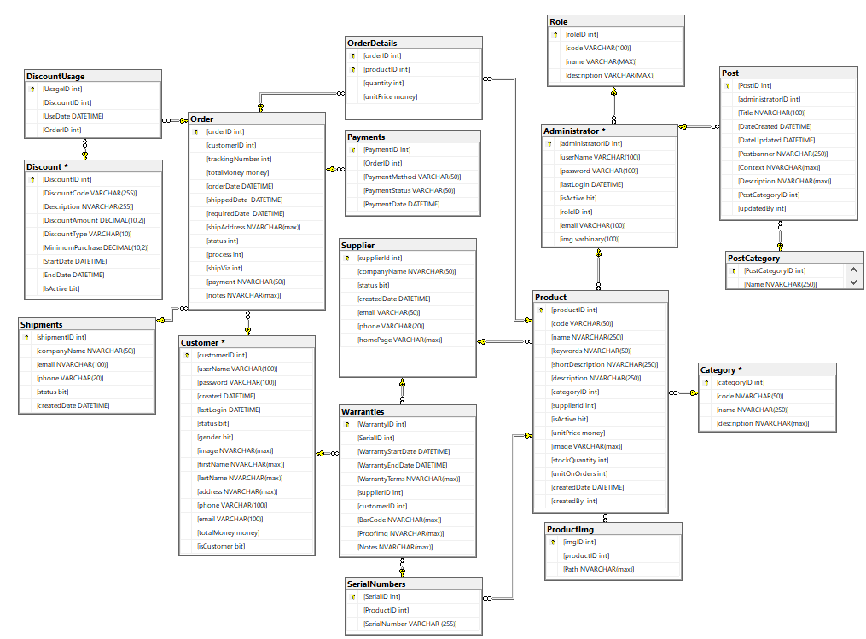

**b. Table Desccription**

|  |  |  |
| --- | --- | --- |
| **No** | **Table** | **Description** |
| 01 | Product | The Product table stores information about the products available in the inventory.  - Primary key: productID  - Foreign keys: categoryID, supplierID, createdBy |
| 02 | ProductImg | The ProductImg table stores information about images associated with products.  - Primary key: imgID  - Foreign keys: productID |
| 03 | Category | The Category table stores information about the different categories into which products are classified.  - Primary key: categoryID  - Foreign keys: |
| 04 | Administrator | The Administrator table stores information about the administrators who manage the system and has the highest level of access of system.  - Primary key: administratorID  - Foreign keys: roleID |
| 05 | Role | The Role table stores information about the different management roles available within the system, which are admin and staff.  - Primary key: roleID  - Foreign keys: |
| 06 | Post | The Post table stores information about news articles or posts published within a system. This table is essential for managing content such as news updates, blog posts, or announcements.  - Primary key: PostID  - Foreign keys: PostCategoryID |
| 07 | PostCategory | The Post (or News) table stores information about news articles or posts published within the system. Each post belongs to one category, but each category can have multiple posts.  - Primary key: PostCategoryID  - Foreign keys: |
| 08 | Supplier | The Supplier table stores information about the suppliers from whom the organization purchases products or services.  - Primary key: supplierID  - Foreign keys: |
| 09 | Warranty | The Warranty table stores information about product warranties offered by the company to its customers. This table is essential for managing warranty-related data, tracking warranty periods, and providing support to customers when issues arise with products.  - Primary key: WarrantyID  - Foreign keys: SerialID, customerID, supplierID |
| 10 | SerialNumber | The SerialNumber table stores information about individual product serial numbers. Each entry in this table represents a unique serial number associated with a specific product.  - Primary key: SerialID  - Foreign keys: productID |
| 11 | Order | The Order table stores information about customer orders placed within the system. Each entry in this table represents a specific order made by a customer, containing details such as the products purchased, quantities, prices.  - Primary key: orderID  - Foreign keys: customerID, shipVia |
| 12 | Order Detail | The OrderDetail table stores detailed information about the products included in each customer order. Each entry in this table represents a specific product item within an order, containing details such as the product ID, quantity ordered, price.  - Primary key: orderID, productID  - Foreign keys: orderID, productID |
| 13 | Payment | The Payment table stores information about payments made by customers for their orders. Each entry in this table represents a specific payment transaction, containing details such as the payment method, amount, and transaction status.  - Primary key: PaymentID  - Foreign keys: orderID |
| 14 | Customer | The Customer table stores information about individual customers who interact with the system and made orders.  - Primary key: customerID  - Foreign keys: |
| 15 | Discount | The Discount table stores information about discounts that are applicable to orders within the system.  - Primary key: DiscountID  - Foreign keys: |
| 16 | Discount Usage | The DiscountUsage table stores information about the usage of discount codes by orders within the system.  - Primary key: UsageID  - Foreign keys: DiscountID, orderID |
| 17 | Shipment | The Shipment table stores information about shipments associated with orders within the system.  - Primary key: shipmentID  - Foreign keys: |

### 3.2 Code package

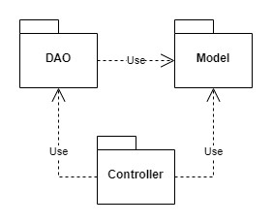

|  |  |  |
| --- | --- | --- |
| **No** | **Package** | **Description** |
| 01 | Model | The model package contains model classes representing data in the application. These model classes are typically used to store and manipulate data, and they interact with DAO classes to access and update data in the database. Each model class typically represents a specific object in the application. The naming convention for model classes often starts with an uppercase letter, followed by consecutive words written together without spaces, describing the characteristics of the data. Example: ‘Customer’ |
| 02 | DAO | The DAO (Data Access Object) package contains classes responsible for interacting with the database. DAO classes typically handle tasks such as querying data, inserting new records, updating existing records, and deleting records from the database. The naming convention for DAO classes often includes the name of the entity or group of entities being accessed, followed by the term "DAO" to indicate its purpose. Example: ‘CustomerDAO’. |
| 03 | Controller | The Controller package contains classes responsible for handling incoming requests, processing them, and coordinating the overall flow of the application. In a Servlet-based application, controllers are typically implemented as Servlet classes or other components that receive requests from clients, perform necessary operations, and then return an appropriate response. |

# **II. Requirement Specifications**

## 1. Common Functions

### 1.1 Register Account

**Functional Description Template**

|  |  |  |  |
| --- | --- | --- | --- |
| UC ID and Name: | UC-1: Register Account | | |
| Created By: | Anhthv | Date Created: | 19/5/2024 |
| Primary Actor: | Customer, guest | Secondary Actors: |  |
| Trigger: | User want to create an account | | |
| Description: | User want to use more function of the system and the first thing they need to do is to register an account | | |
| Preconditions: | Have access to internet  Access the website | | |
| Postconditions: | Create account successfully | | |
| Normal Flow: | 1. User visit the website  2. User click on button signup  3. System display signup form  4. User enter information (username, password, gender, firstname, lastname, address, phone number, email)  5. User click on signup button | | |
| Alternative Flows: | N/A | | |
| Exceptions: | 4a. Email or Phone number have already been use  4b. User haven’t input all data field | | |
| Priority: | High | | |
| Frequency of Use: | High | | |
| Business Rules: |  | | |
| Other Information: |  | | |
| Assumptions: |  | | |

### 1.2 Login

**Functional Description Template**

|  |  |  |  |
| --- | --- | --- | --- |
| UC ID and Name: | UC-2: login | | |
| Created By: | Anhthv | Date Created: | 19/5/2024 |
| Primary Actor: | Customer, guest, Admin | Secondary Actors: |  |
| Trigger: | User want to login | | |
| Description: | The user login into the system in order to use more function | | |
| Preconditions: | Have access to internet  Access the website | | |
| Postconditions: | login successfully | | |
| Normal Flow: | 1. User visit the website  2. User click on button login  3. System display login form  4. User enter information (username, password)  5. User click on login button  6. System redirect user to home screen | | |
| Alternative Flows: | N/A | | |
| Exceptions: | 5a. Error message: Incorrect username or password  5b. Error message: Account or password field is empty | | |
| Priority: | High | | |
| Frequency of Use: | High | | |
| Business Rules: |  | | |
| Other Information: |  | | |
| Assumptions: |  | | |

### 1.3 Forgot Password

**Functional Description Template**

|  |  |  |  |
| --- | --- | --- | --- |
| UC ID and Name: | UC-3: Forgot Password | | |
| Created By: | Anhthv | Date Created: | 19/5/2024 |
| Primary Actor: | Customer, Guest | Secondary Actors: |  |
| Trigger: | User forgot their password | | |
| Description: |  | | |
| Preconditions: | Have access to internet  Access the website | | |
| Postconditions: | User reset their password successfully | | |
| Normal Flow: | 1. User visit the website  2. User click on forgot password | | |
| Alternative Flows: | N/A | | |
| Exceptions: |  | | |
| Priority: | Normal | | |
| Frequency of Use: |  | | |
| Business Rules: |  | | |
| Other Information: |  | | |
| Assumptions: |  | | |

### 1.4 Logout

**Functional Description Template**

|  |  |  |  |
| --- | --- | --- | --- |
| UC ID and Name: | UC-4: Logout | | |
| Created By: | Anhthv | Date Created: | 19/5/2024 |
| Primary Actor: | Customer, Guest, Admin | Secondary Actors: |  |
| Trigger: | User want to logout | | |
| Description: | The user logout of their account | | |
| Preconditions: | Have access to internet  Access the website  User is login | | |
| Postconditions: | Logout successfully | | |
| Normal Flow: | 1. User click on button logut  2. System redirect user to home screen | | |
| Alternative Flows: | N/A | | |
| Exceptions: | N/A | | |
| Priority: | High | | |
| Frequency of Use: | High | | |
| Business Rules: |  | | |
| Other Information: |  | | |
| Assumptions: |  | | |

## 2. Admin Functions

### 2.1 Account Management

#### 2.1.1 View List Account

**Functional Description Template**

|  |  |  |  |
| --- | --- | --- | --- |
| UC ID and Name: | UC-2.1.1: View List Account | | |
| Created By: | Anhthv | Date Created: | 19/5/2024 |
| Primary Actor: | Admin | Secondary Actors: |  |
| Trigger: | Admin click on tab Account on the left menu | | |
| Description: | System redirect admin to account management screen, with a list of account | | |
| Preconditions: | Have access to internet  Access the website  Login as admin | | |
| Postconditions: | Can see a list account | | |
| Normal Flow: | 1. Click on tab account  2. System show a list off account | | |
| Alternative Flows: | N/A | | |
| Exceptions: | N/A | | |
| Priority: | High | | |
| Frequency of Use: | High | | |
| Business Rules: |  | | |
| Other Information: |  | | |
| Assumptions: |  | | |

#### 2.1.2 Ban Account

**Functional Description Template**

|  |  |  |  |
| --- | --- | --- | --- |
| UC ID and Name: | UC-2.1.2: Ban Account | | |
| Created By: | Anhthv | Date Created: | 19/5/2024 |
| Primary Actor: | Admin | Secondary Actors: |  |
| Trigger: | Admin click on ban button | | |
| Description: | Admin can ban an account | | |
| Preconditions: | Have access to internet  Access the website  Login as admin | | |
| Postconditions: | Ban an user account | | |
| Normal Flow: | 1. Click on tab account  2. Click on button ban  3. User is ban | | |
| Alternative Flows: | N/A | | |
| Exceptions: | N/A | | |
| Priority: | High | | |
| Frequency of Use: | High | | |
| Business Rules: |  | | |
| Other Information: |  | | |
| Assumptions: |  | | |

#### 2.1.3 Unban Account

**Functional Description Template**

|  |  |  |  |
| --- | --- | --- | --- |
| UC ID and Name: | UC-2.1.3: Unban Account | | |
| Created By: | Anhthv | Date Created: | 19/5/2024 |
| Primary Actor: | Admin | Secondary Actors: |  |
| Trigger: | Admin click on button unban | | |
| Description: | Admin can unban an user account | | |
| Preconditions: | Have access to internet  Access the website  Login as admin | | |
| Postconditions: | Unban an user account | | |
| Normal Flow: | 1. Click on tab account  2. Click on button unban  3. User is unban | | |
| Alternative Flows: | N/A | | |
| Exceptions: | N/A | | |
| Priority: | High | | |
| Frequency of Use: | High | | |
| Business Rules: |  | | |
| Other Information: |  | | |
| Assumptions: |  | | |

### 2.2 Category Management

#### 2.2.1 View List Category

**Functional Description Template**

|  |  |  |  |
| --- | --- | --- | --- |
| UC ID and Name: | UC-2.2.1: View List Category | | |
| Created By: | Anhthv | Date Created: | 19/5/2024 |
| Primary Actor: | Admin | Secondary Actors: |  |
| Trigger: | Admin click on tab Category on the left menu | | |
| Description: | System redirect admin to Category Management screen, with a list of all category | | |
| Preconditions: | Have access to internet  Access the website  Login as admin | | |
| Postconditions: | View list category | | |
| Normal Flow: | 1. Click on tab Category  2. System show a list of all category | | |
| Alternative Flows: | N/A | | |
| Exceptions: | N/A | | |
| Priority: | High | | |
| Frequency of Use: | High | | |
| Business Rules: |  | | |
| Other Information: |  | | |
| Assumptions: |  | | |

#### 2.2.2 Add Category

**Functional Description Template**

|  |  |  |  |
| --- | --- | --- | --- |
| UC ID and Name: | UC-2.2.2: Add Category | | |
| Created By: | Anhthv | Date Created: | 19/5/2024 |
| Primary Actor: | Admin | Secondary Actors: |  |
| Trigger: | Admin click on button “Add” | | |
| Description: | Admin can add a new category | | |
| Preconditions: | Have access to internet  Access the website  Login as admin | | |
| Postconditions: | Add a new Category | | |
| Normal Flow: | 1. Click on tab Category  2. Click on button “Add Category”  3. Admin is redirect to page to add category  4. Admin enter new Category info (category code, name, description)  5. Admin click button “Add”  6. Category is add, admin is redirect back to List category | | |
| Alternative Flows: | N/A | | |
| Exceptions: |  | | |
| Priority: | High | | |
| Frequency of Use: | High | | |
| Business Rules: |  | | |
| Other Information: |  | | |
| Assumptions: |  | | |

#### 2.2.3 Update Category

**Functional Description Template**

|  |  |  |  |
| --- | --- | --- | --- |
| UC ID and Name: | UC-2.2.3: Update Category | | |
| Created By: | Anhthv | Date Created: | 19/5/2024 |
| Primary Actor: | Admin | Secondary Actors: |  |
| Trigger: | Admin click on “Edit” button | | |
| Description: | Admin can edit the content of an category | | |
| Preconditions: | Have access to internet  Access the website  Login as admin | | |
| Postconditions: | Update Category | | |
| Normal Flow: | 1. Click on tab Category  2. Click on button “Edit”  3. Admin is redirect to page to edit category  4. Admin enter new Category info (category code, name, description)  5. Admin click button “Edit”  6. Category is update, admin is redirect back to List category | | |
| Alternative Flows: | N/A | | |
| Exceptions: |  | | |
| Priority: | High | | |
| Frequency of Use: | High | | |
| Business Rules: |  | | |
| Other Information: |  | | |
| Assumptions: |  | | |

#### 2.2.4 Delete Category

**Functional Description Template**

|  |  |  |  |
| --- | --- | --- | --- |
| UC ID and Name: | UC-2.2.3: Delete Category | | |
| Created By: | Anhthv | Date Created: | 19/5/2024 |
| Primary Actor: | Admin | Secondary Actors: |  |
| Trigger: | Admin click on “Delete” button | | |
| Description: | Admin can delete a category | | |
| Preconditions: | Have access to internet  Access the website  Login as admin | | |
| Postconditions: | Delete Category | | |
| Normal Flow: | 1. Click on tab Category  2. Click on button “Delete”  3. System show a dialog to ask “Are you sure you want to delete”  4. Admin click yes  5. The category is delete | | |
| Alternative Flows: | N/A | | |
| Exceptions: |  | | |
| Priority: | High | | |
| Frequency of Use: | High | | |
| Business Rules: |  | | |
| Other Information: |  | | |
| Assumptions: |  | | |

### 2.3 Product Management

#### 2.3.1 View List Product

**Functional Description Template**

|  |  |  |  |
| --- | --- | --- | --- |
| UC ID and Name: | UC-2.3.1: View List Product | | |
| Created By: | Anhthv | Date Created: | 19/5/2024 |
| Primary Actor: | Admin | Secondary Actors: |  |
| Trigger: | Admin click on tab Product on the left menu | | |
| Description: | System redirect admin to Product Management screen, and show a list of all product | | |
| Preconditions: | Have access to internet  Access the website  Login as admin | | |
| Postconditions: | Can see a list product | | |
| Normal Flow: | 1. Click on tab account  2. System show a list off product | | |
| Alternative Flows: | N/A | | |
| Exceptions: | N/A | | |
| Priority: | High | | |
| Frequency of Use: | High | | |
| Business Rules: |  | | |
| Other Information: |  | | |
| Assumptions: |  | | |

#### 2.3.2 Add Product

**Functional Description Template**

|  |  |  |  |
| --- | --- | --- | --- |
| UC ID and Name: | UC-2.3.2: Add Product | | |
| Created By: | Anhthv | Date Created: | 19/5/2024 |
| Primary Actor: | Admin | Secondary Actors: |  |
| Trigger: | Admin click on “Add” button | | |
| Description: | Admin can add a new product | | |
| Preconditions: | Have access to internet  Access the website  Login as admin | | |
| Postconditions: | Add a new product | | |
| Normal Flow: | 1. Click on tab product  2. Click on button “Add Product”  3. Admin is redirect to page to add product  4. Admin enter new Product info:   * Name * Keyword * Short description * Description * Category * Supplier * Unitprice * Image * Stock   5. Admin click button “Add”  6. New product is add, admin is redirect back to List product | | |
| Alternative Flows: | N/A | | |
| Exceptions: |  | | |
| Priority: | High | | |
| Frequency of Use: | High | | |
| Business Rules: |  | | |
| Other Information: |  | | |
| Assumptions: |  | | |

#### 2.3.3 Update Product

**Functional Description Template**

|  |  |  |  |
| --- | --- | --- | --- |
| UC ID and Name: | UC-2.3.3: Update Product | | |
| Created By: | Anhthv | Date Created: | 19/5/2024 |
| Primary Actor: | Admin | Secondary Actors: |  |
| Trigger: | Admin click on “Edit” button | | |
| Description: | Admin can edit the info of a product | | |
| Preconditions: | Have access to internet  Access the website  Login as admin | | |
| Postconditions: | Update product | | |
| Normal Flow: | 1. Click on tab Product  2. Click on button “Edit”  3. Admin is redirect to page to edit product  4. Admin enter new Product info:   * Name * Keyword * Short description * Description * Category * Supplier * Unitprice * Image * Stock   5. Admin click button “Edit”  6. Product is update, admin is redirect back to List product | | |
| Alternative Flows: | N/A | | |
| Exceptions: |  | | |
| Priority: | High | | |
| Frequency of Use: | High | | |
| Business Rules: |  | | |
| Other Information: |  | | |
| Assumptions: |  | | |

#### 2.3.4 Delete Product

**Functional Description Template**

|  |  |  |  |
| --- | --- | --- | --- |
| UC ID and Name: | UC-2.3.4: Delete Product | | |
| Created By: | Anhthv | Date Created: | 19/5/2024 |
| Primary Actor: | Admin | Secondary Actors: |  |
| Trigger: | Admin click on “Delete” button | | |
| Description: | Admin can delete a product | | |
| Preconditions: | Have access to internet  Access the website  Login as admin | | |
| Postconditions: | Delete Product | | |
| Normal Flow: | 1. Click on tab Product  2. Click on button “Delete”  3. System show a dialog to ask “Are you sure you want to delete”  4. Admin click yes  5. The product is delete | | |
| Alternative Flows: | N/A | | |
| Exceptions: |  | | |
| Priority: | High | | |
| Frequency of Use: | High | | |
| Business Rules: |  | | |
| Other Information: |  | | |
| Assumptions: |  | | |

### 2.4 News Management

#### 2.4.1 Add News

**Functional Description Template**

|  |  |  |  |
| --- | --- | --- | --- |
| UC ID and Name: | UC-2.4.1: Add News | | |
| Created By: | Anhthv | Date Created: | 19/5/2024 |
| Primary Actor: | Admin | Secondary Actors: |  |
| Trigger: | Admin click on tab News on the left menu | | |
| Description: | System redirect admin to News Management screen, and show a list of all news | | |
| Preconditions: | Have access to internet  Access the website  Login as admin | | |
| Postconditions: | Add a new news | | |
| Normal Flow: | 1. Click on tab “News”  2. Click on button “Add News”  3. Admin is redirect to page to add news  4. Admin enter new News info:   * Title * Post banner * Description   5. Admin click button “Add”  6. New news is add | | |
| Alternative Flows: | N/A | | |
| Exceptions: | N/A | | |
| Priority: | High | | |
| Frequency of Use: | High | | |
| Business Rules: |  | | |
| Other Information: |  | | |
| Assumptions: |  | | |

#### 2.4.2 Update News

**Functional Description Template**

|  |  |  |  |
| --- | --- | --- | --- |
| UC ID and Name: | UC-2.4.2: Update News | | |
| Created By: | Anhthv | Date Created: | 19/5/2024 |
| Primary Actor: | Admin | Secondary Actors: |  |
| Trigger: | Admin click on “Edit” button | | |
| Description: | Admin can edit the content of a news | | |
| Preconditions: | Have access to internet  Access the website  Login as admin | | |
| Postconditions: | Update product | | |
| Normal Flow: | 1. Click on tab “News”  2. Click on button “Edit”  3. Admin is redirect to page to edit news  4. Admin enter new News info:   * Title * Post banner * Description   5. Admin click button “Edit”  6. News is update | | |
| Alternative Flows: | N/A | | |
| Exceptions: |  | | |
| Priority: | High | | |
| Frequency of Use: | High | | |
| Business Rules: |  | | |
| Other Information: |  | | |
| Assumptions: |  | | |

#### 2.4.3 Delete News

**Functional Description Template**

|  |  |  |  |
| --- | --- | --- | --- |
| UC ID and Name: | UC-2.4.3: Delete News | | |
| Created By: | Anhthv | Date Created: | 19/5/2024 |
| Primary Actor: | Admin | Secondary Actors: |  |
| Trigger: | Admin click on “Delete” button | | |
| Description: | Admin can delete a news | | |
| Preconditions: | Have access to internet  Access the website  Login as admin | | |
| Postconditions: | Delete Product | | |
| Normal Flow: | 1. Click on tab News  2. Click on button “Delete”  3. System show a dialog to ask “Are you sure you want to delete”  4. Admin click yes  5. The news is delete | | |
| Alternative Flows: | N/A | | |
| Exceptions: |  | | |
| Priority: | High | | |
| Frequency of Use: | High | | |
| Business Rules: |  | | |
| Other Information: |  | | |
| Assumptions: |  | | |

### 2.5 Supplier Management

#### 2.5.1 View List Supplier

**Functional Description Template**

|  |  |  |  |
| --- | --- | --- | --- |
| UC ID and Name: | UC-2.5.1: View List Supplier | | |
| Created By: | Anhthv | Date Created: | 19/5/2024 |
| Primary Actor: | Admin | Secondary Actors: |  |
| Trigger: | Admin click on tab Supplier on the left menu | | |
| Description: | System redirect admin to Supplier Management screen, and show a list of all supplier | | |
| Preconditions: | Have access to internet  Access the website  Login as admin | | |
| Postconditions: | View list supplier | | |
| Normal Flow: | 1. Click on tab Supplier  2. System show a list of all category | | |
| Alternative Flows: | N/A | | |
| Exceptions: | N/A | | |
| Priority: | High | | |
| Frequency of Use: | High | | |
| Business Rules: |  | | |
| Other Information: |  | | |
| Assumptions: |  | | |

#### 2.5.2 Add Supplier

**Functional Description Template**

|  |  |  |  |
| --- | --- | --- | --- |
| UC ID and Name: | UC-2.5.2: Add Supplier | | |
| Created By: | Anhthv | Date Created: | 19/5/2024 |
| Primary Actor: | Admin | Secondary Actors: |  |
| Trigger: | Admin click on “Add” button | | |
| Description: | Admin can add a new supplier | | |
| Preconditions: | Have access to internet  Access the website  Login as admin | | |
| Postconditions: | Add a new supplier | | |
| Normal Flow: | 1. Click on tab “Supplier”  2. Click on button “Add Supplier”  3. Admin is redirect to page to add supplier  4. Admin enter new Supplier info:   * Company name * Email * Phone * Home page   5. Admin click button “Add”  6. New supplier is add | | |
| Alternative Flows: | N/A | | |
| Exceptions: |  | | |
| Priority: | High | | |
| Frequency of Use: | High | | |
| Business Rules: |  | | |
| Other Information: |  | | |
| Assumptions: |  | | |

#### 2.5.3 Update Supplier

**Functional Description Template**

|  |  |  |  |
| --- | --- | --- | --- |
| UC ID and Name: | UC-2.5.3: Update Supplier | | |
| Created By: | Anhthv | Date Created: | 19/5/2024 |
| Primary Actor: | Admin | Secondary Actors: |  |
| Trigger: | Admin click on “Edit” button | | |
| Description: | Admin can edit a supplier info | | |
| Preconditions: | Have access to internet  Access the website  Login as admin | | |
| Postconditions: | Update supplier | | |
| Normal Flow: | 1. Click on tab “Supplier”  2. Click on button “Edit”  3. Admin is redirect to page to edit supplier  4. Admin enter new Supplier info:   * Company name * Email * Phone * Home page   5. Admin click button “Edit”  6. Supplier is update | | |
| Alternative Flows: | N/A | | |
| Exceptions: |  | | |
| Priority: | High | | |
| Frequency of Use: | High | | |
| Business Rules: |  | | |
| Other Information: |  | | |
| Assumptions: |  | | |

#### 2.5.4 Delete Supplier

**Functional Description Template**

|  |  |  |  |
| --- | --- | --- | --- |
| UC ID and Name: | UC-2.5.4: Delete Supplier | | |
| Created By: | Anhthv | Date Created: | 19/5/2024 |
| Primary Actor: | Admin | Secondary Actors: |  |
| Trigger: | Admin click on “Delete” button | | |
| Description: | Admin can delete a supplier | | |
| Preconditions: | Have access to internet  Access the website  Login as admin | | |
| Postconditions: | Delete Supplier | | |
| Normal Flow: | 1. Click on tab Supplier  2. Click on button “Delete”  3. System show a dialog to ask “Are you sure you want to delete”  4. Admin click yes  5. The supplier is delete | | |
| Alternative Flows: | N/A | | |
| Exceptions: |  | | |
| Priority: | High | | |
| Frequency of Use: | High | | |
| Business Rules: |  | | |
| Other Information: |  | | |
| Assumptions: |  | | |

### 2.6 Order Management

#### 2.6.1 View List Order

**Functional Description Template**

|  |  |  |  |
| --- | --- | --- | --- |
| UC ID and Name: | UC-2.6.1: View List Order | | |
| Created By: | Anhthv | Date Created: | 19/5/2024 |
| Primary Actor: | Admin | Secondary Actors: |  |
| Trigger: | Admin click on tab Order on the left menu | | |
| Description: | System redirect admin to Order Management screen, and show a list of all order | | |
| Preconditions: | Have access to internet  Access the website  Login as admin | | |
| Postconditions: | View list of order | | |
| Normal Flow: | 1. Click on tab “order”  2. System show a list of all order | | |
| Alternative Flows: | N/A | | |
| Exceptions: | N/A | | |
| Priority: | High | | |
| Frequency of Use: | High | | |
| Business Rules: |  | | |
| Other Information: |  | | |
| Assumptions: |  | | |

#### 2.6.2 Update Order

**Functional Description Template**

|  |  |  |  |
| --- | --- | --- | --- |
| UC ID and Name: | UC-2.6.2: Update Order | | |
| Created By: | Anhthv | Date Created: | 19/5/2024 |
| Primary Actor: | Admin | Secondary Actors: |  |
| Trigger: | Admin click on “Update” button | | |
| Description: | Admin can update an order status | | |
| Preconditions: | Have access to internet  Access the website  Login as admin | | |
| Postconditions: | Update order | | |
| Normal Flow: | 1. Click on tab “Order”  2. Admin change the order status  3. Order is update | | |
| Alternative Flows: | N/A | | |
| Exceptions: |  | | |
| Priority: | High | | |
| Frequency of Use: | High | | |
| Business Rules: |  | | |
| Other Information: |  | | |
| Assumptions: |  | | |

#### 2.6.3 Order Detail

**Functional Description Template**

|  |  |  |  |
| --- | --- | --- | --- |
| UC ID and Name: | UC-2.6.3: Order Detail | | |
| Created By: | Anhthv | Date Created: | 19/5/2024 |
| Primary Actor: | Admin | Secondary Actors: |  |
| Trigger: | Admin click on “Detail” button | | |
| Description: | Admin can view all detail of an order | | |
| Preconditions: | Have access to internet  Access the website  Login as admin | | |
| Postconditions: | View order detail | | |
| Normal Flow: | 1. Click on tab Order  2. Click on button “Detail”  3. System redirect admin to page with all order detail | | |
| Alternative Flows: | N/A | | |
| Exceptions: |  | | |
| Priority: | High | | |
| Frequency of Use: | High | | |
| Business Rules: |  | | |
| Other Information: |  | | |
| Assumptions: |  | | |